**PROBLEM STATEMENT**

Create an account in AWS and configure a budget.

**ACCOUNT CREATION**

1.Sign up. Create a new AWS account.

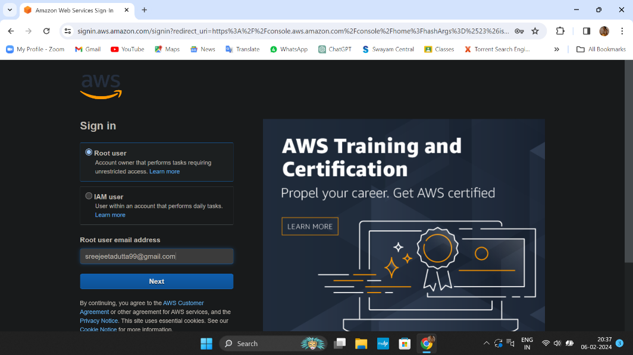

2.Enter root user email address and AWS account name.

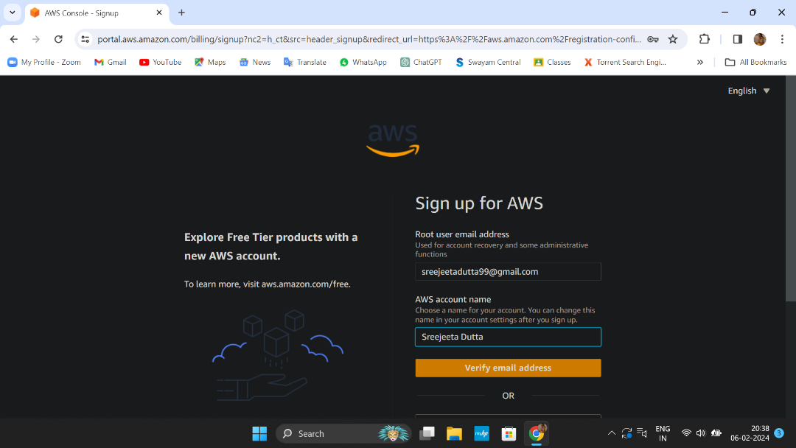

3.Verify your email address. 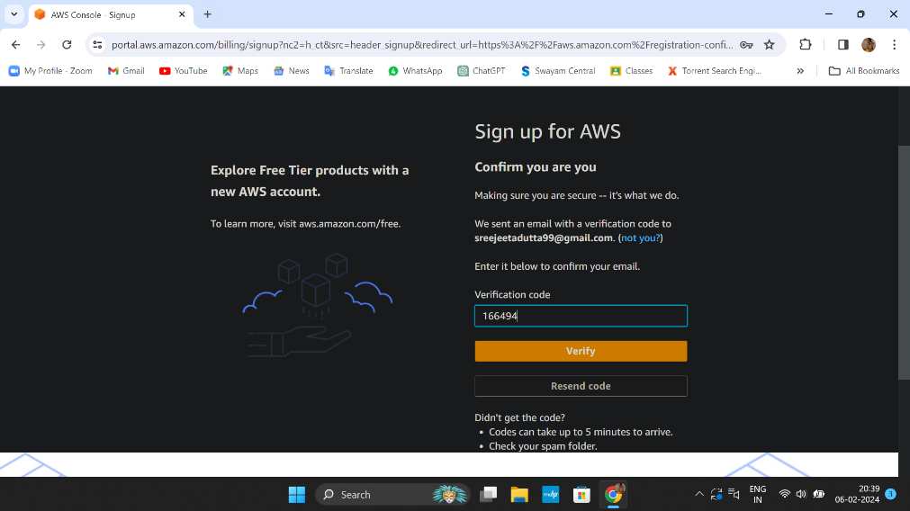

4. Set your password, then click on continue.

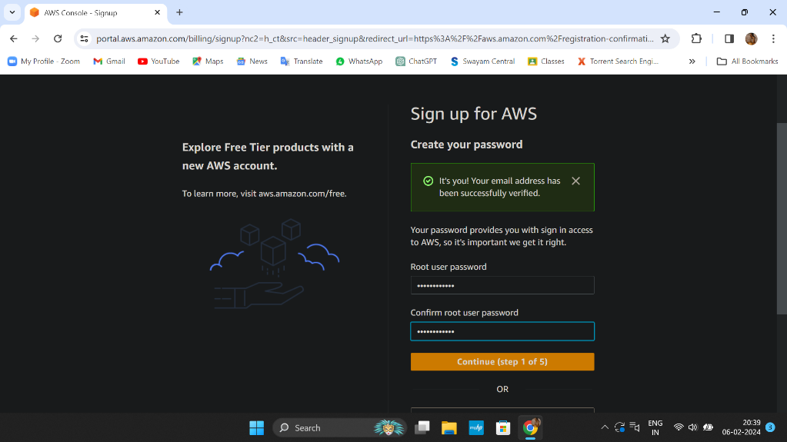

5. Fill the required details, tick off the checkbox and click on continue.

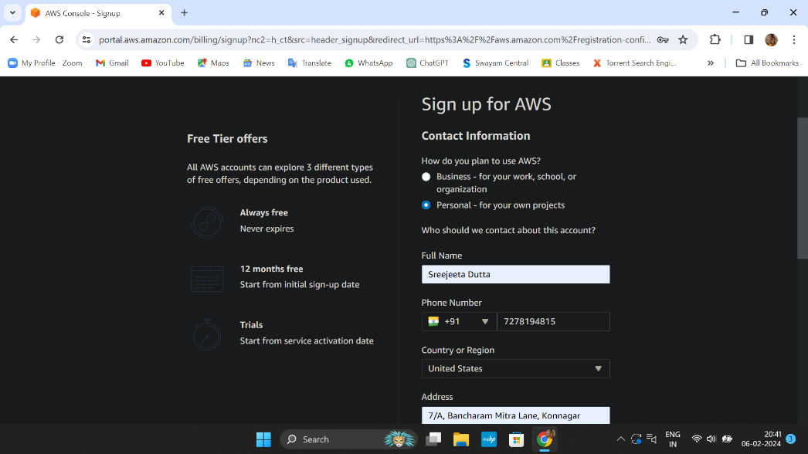

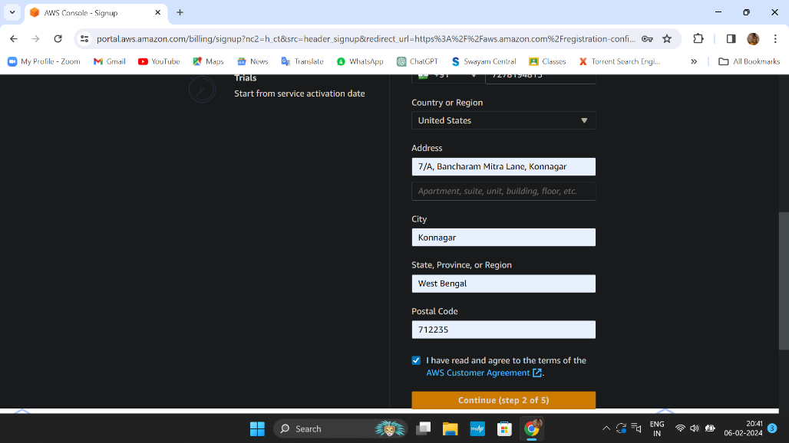

6. Complete payment for successful registration.

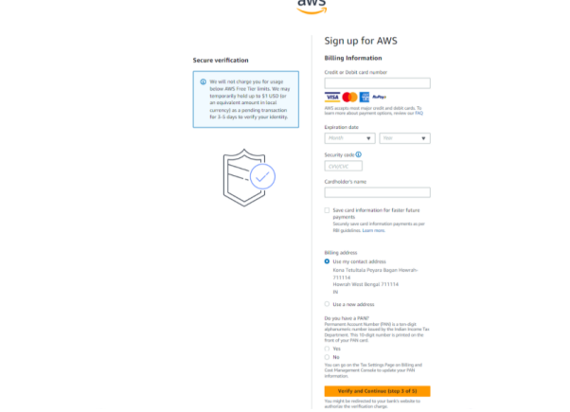

7. Verify your phone number.

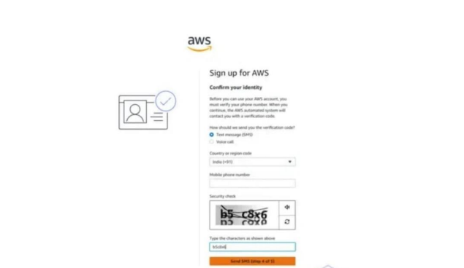

8.Select a support plan.

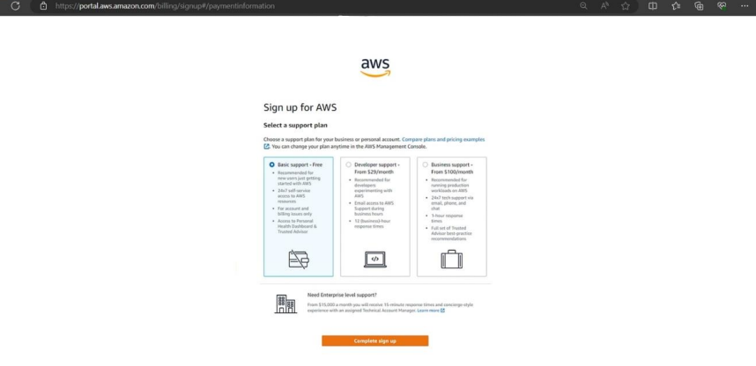

9. The account is successfully created.

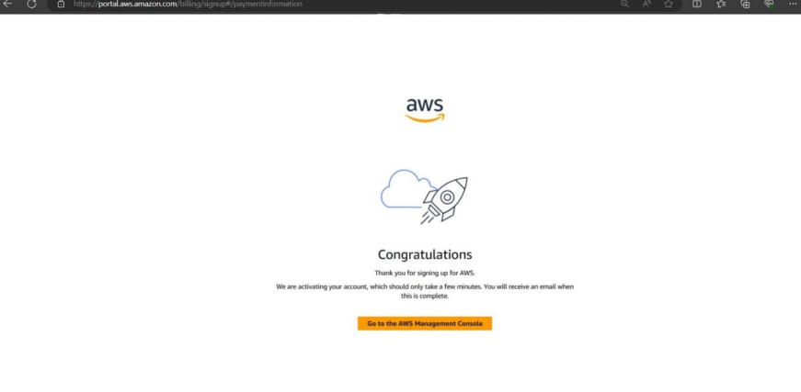

**BUDGET CONFIGURATION**

1. Log in to AWS console ,go to your username and click on ‘Billing and Cost Management’.

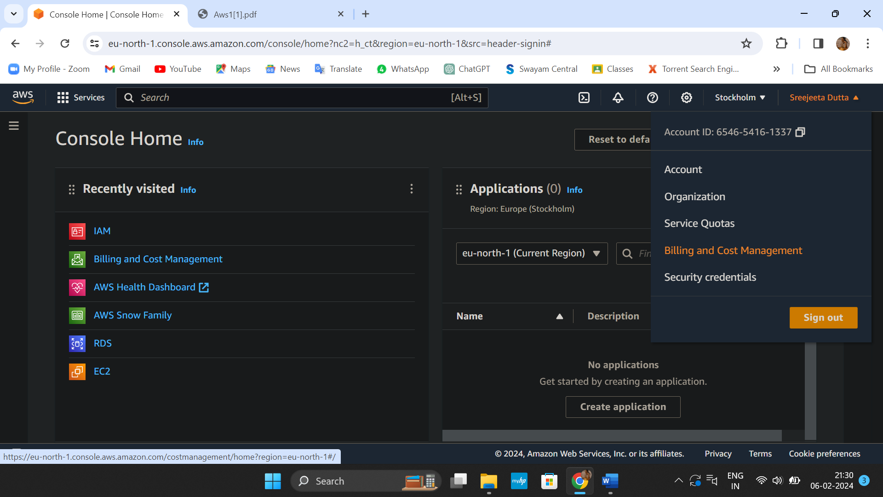

1. Under ‘Budgets and Planning’, click on ‘Budgets’ and create budget.

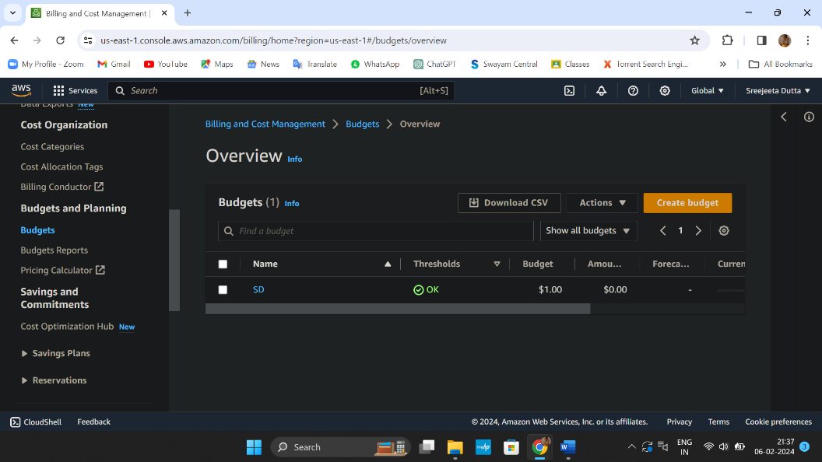

1. Configure budget setup->click on Customize(advanced) then click on next.

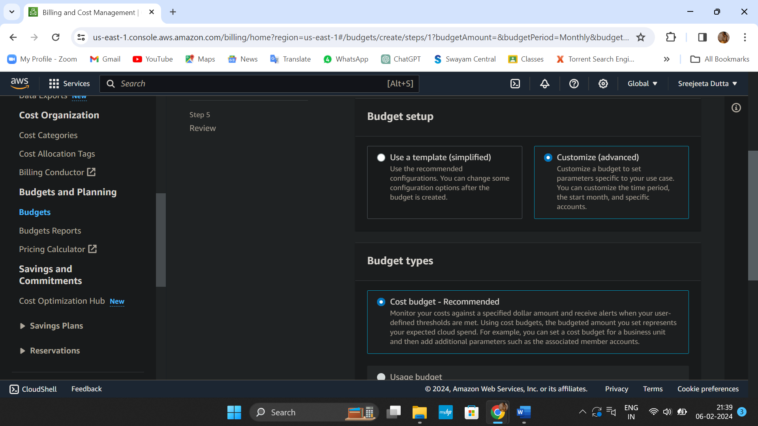

1. Add budget details.

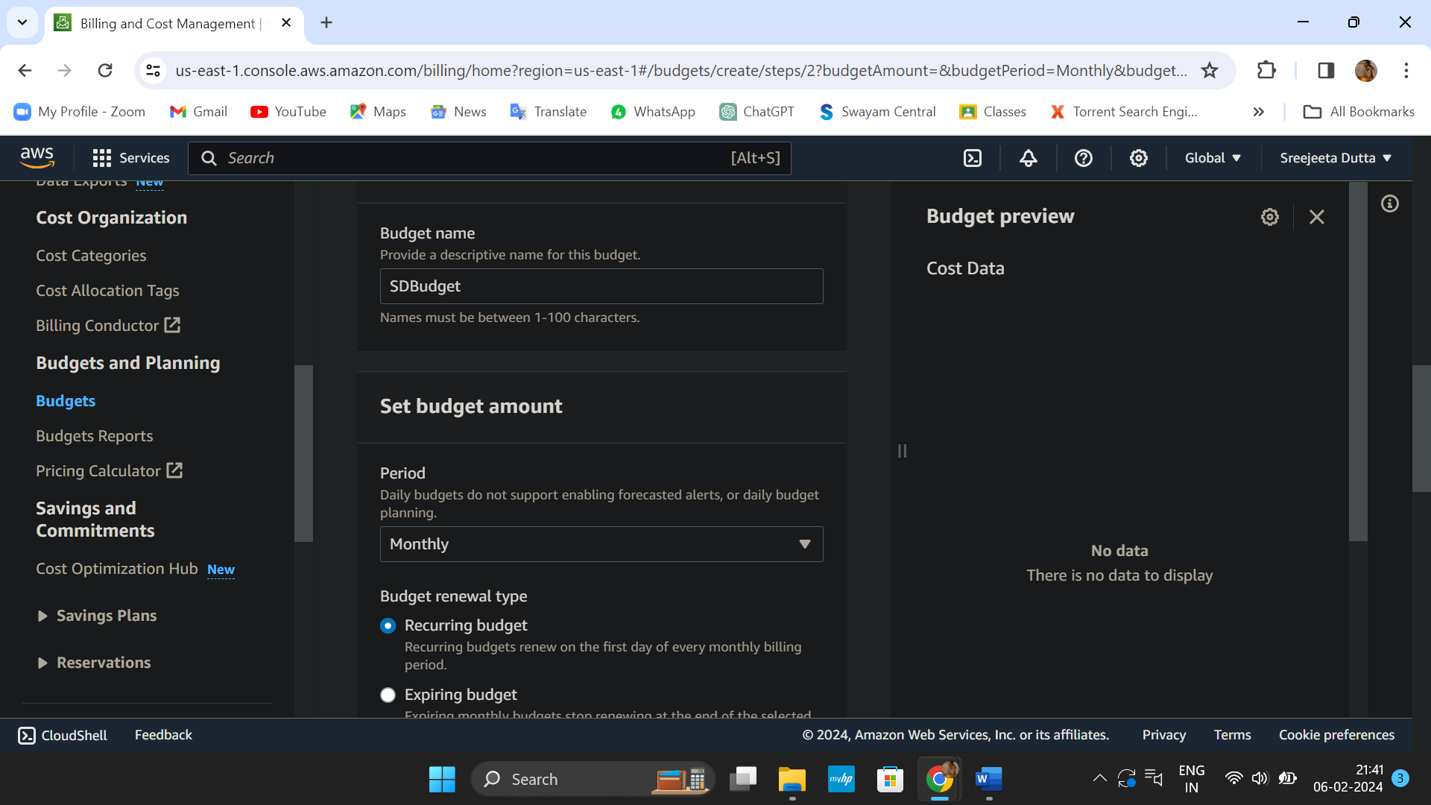

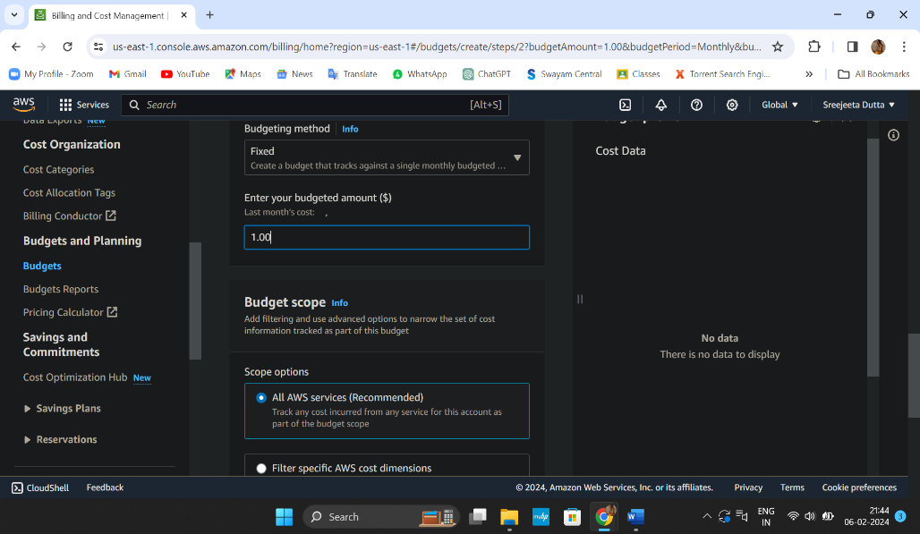

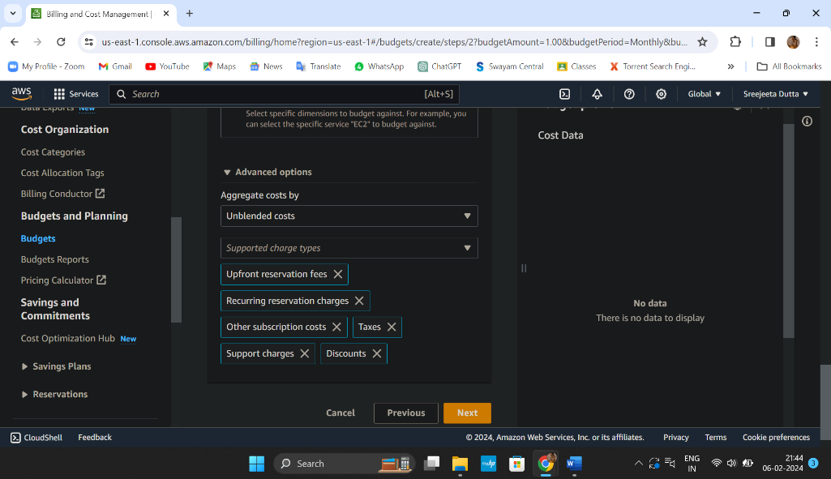

1. Configure alerts->click on ‘Add an alert threshold’.

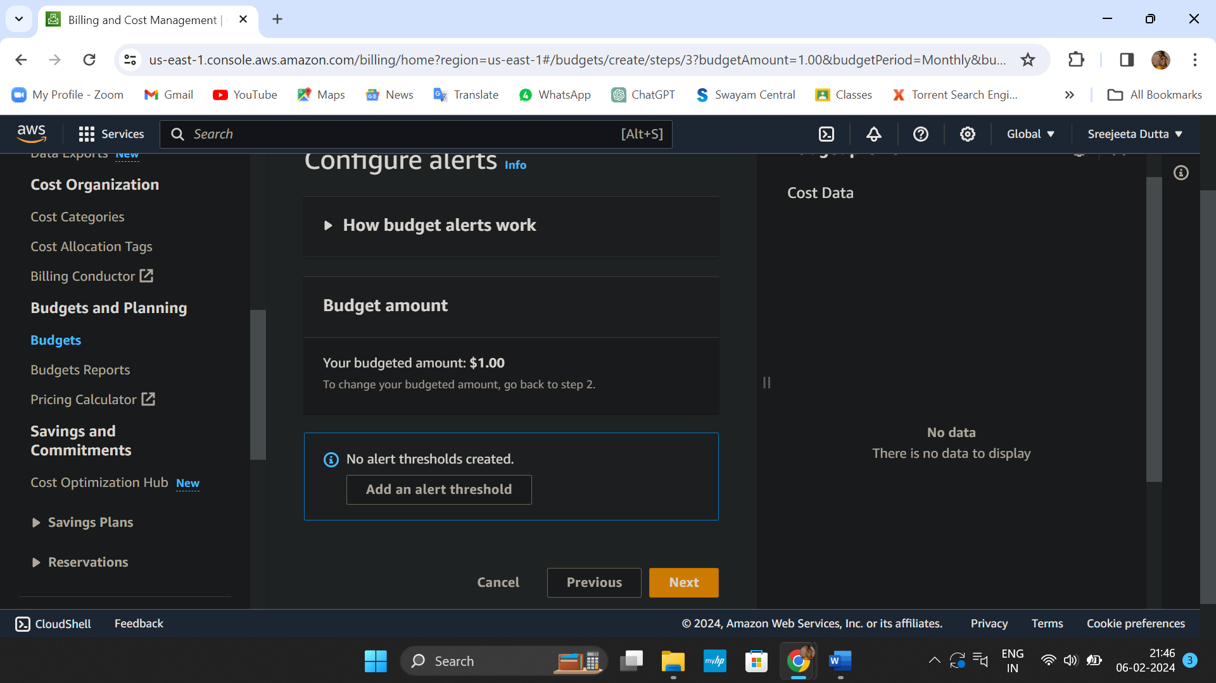

1. Set alert threshold(Alert #1). If we want to create more than one alert threshold then click on ‘Add an alert threshold’ otherwise click on next twice.

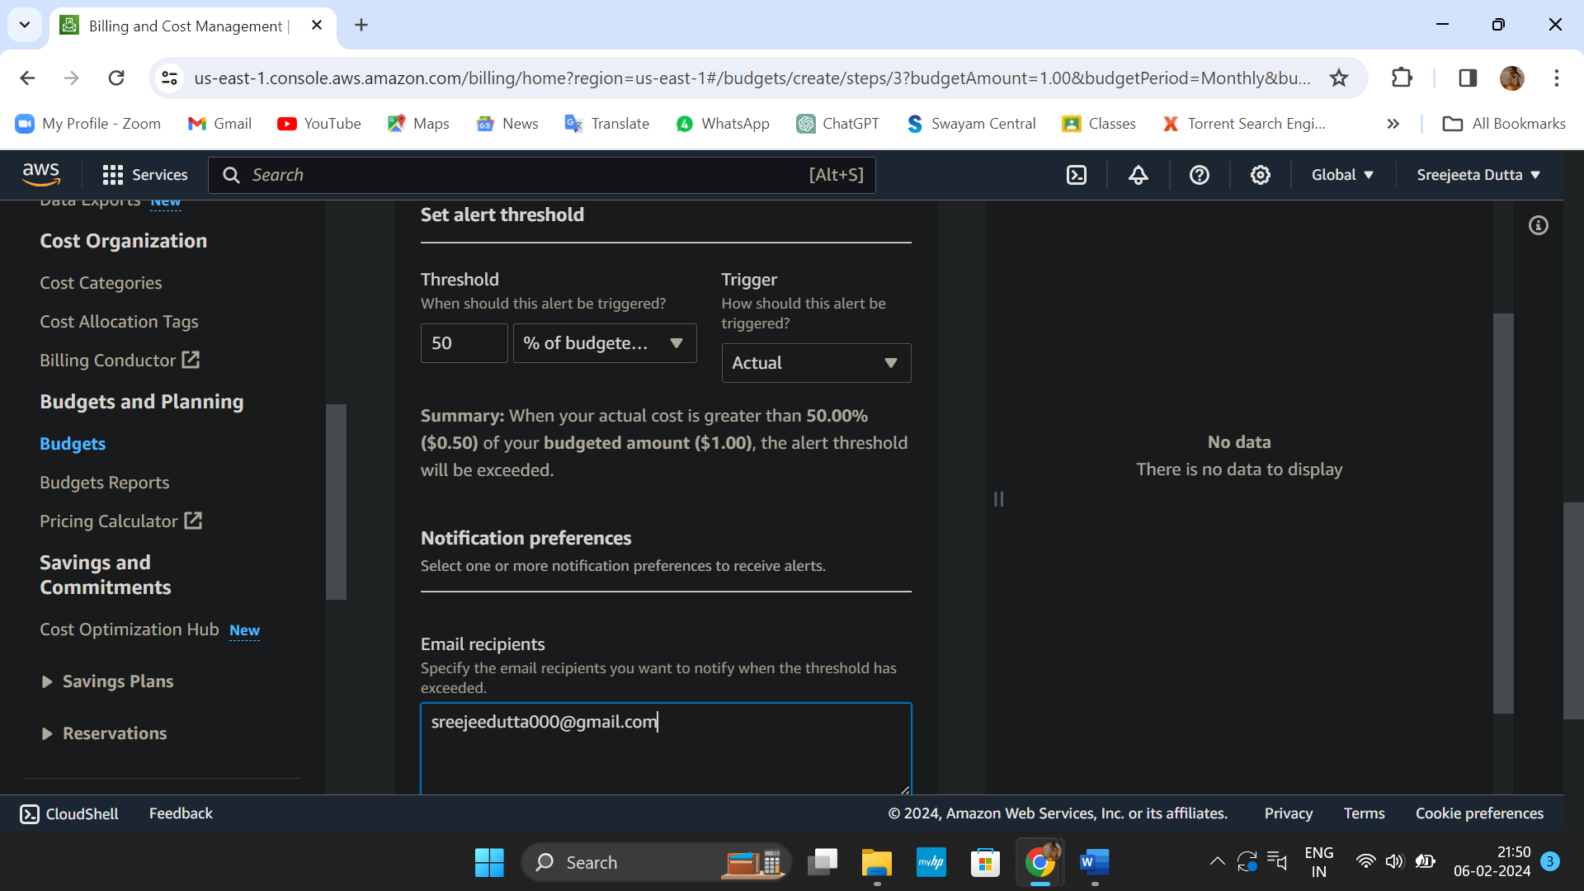

1. We ‘Review’ our budget and for creating it click on ‘Create budget’.

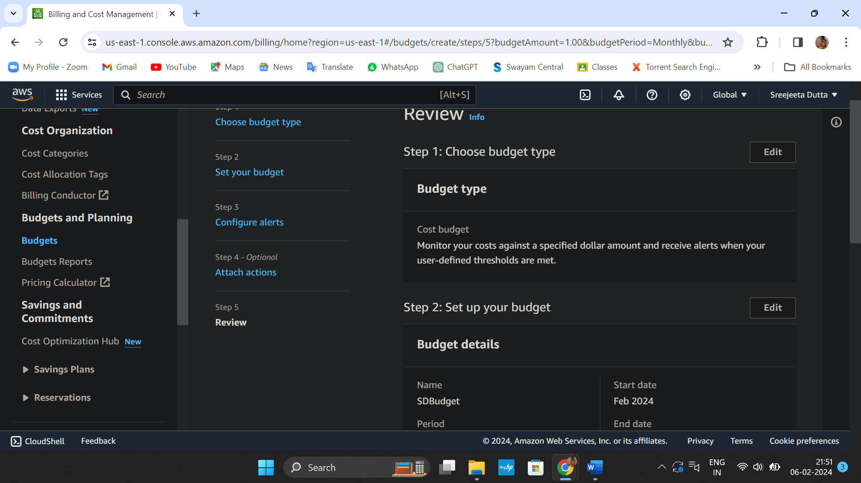

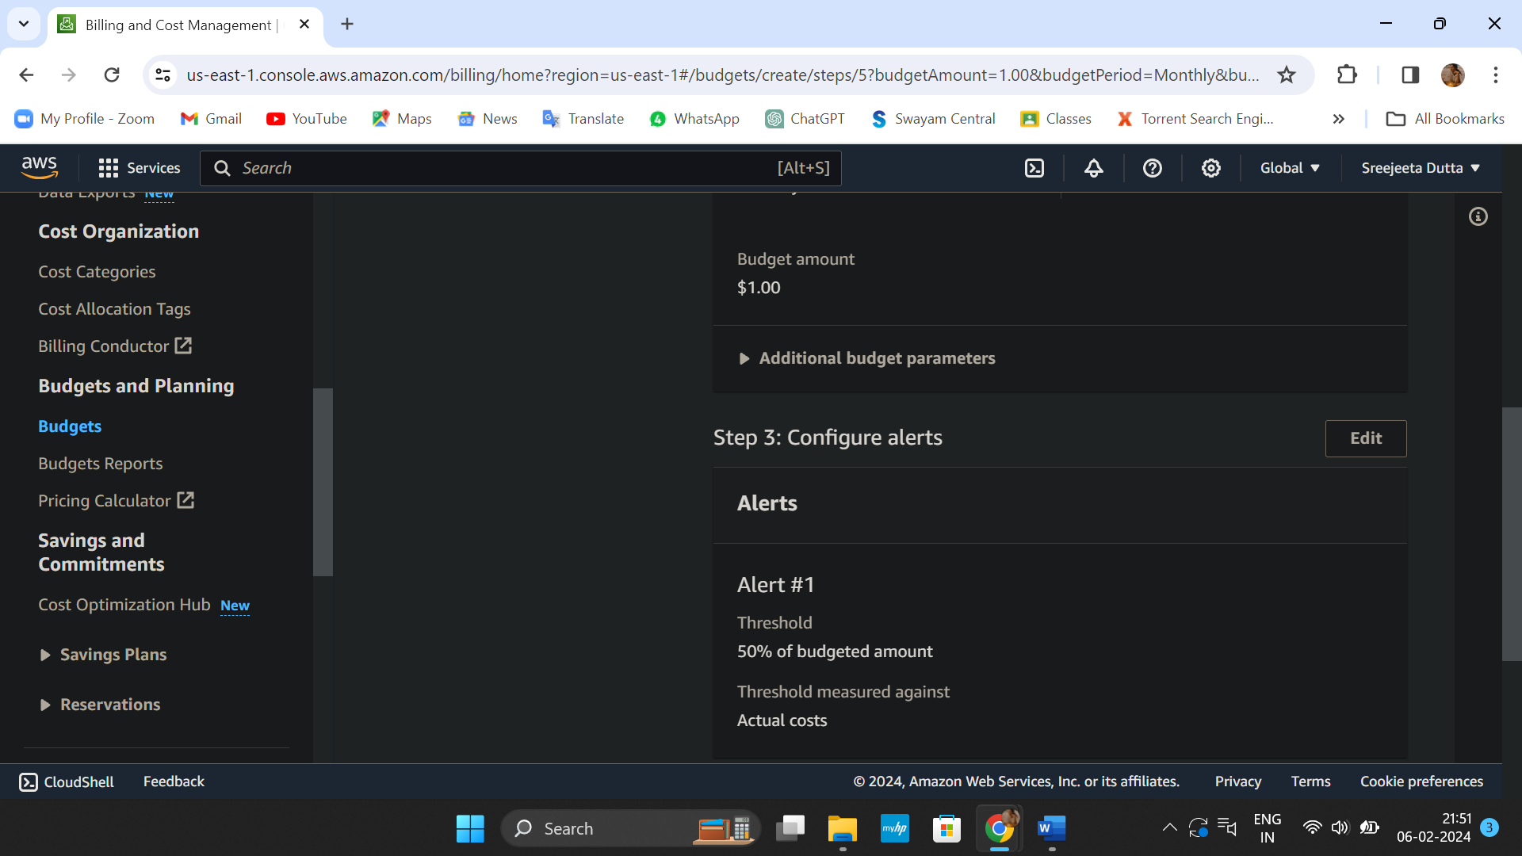

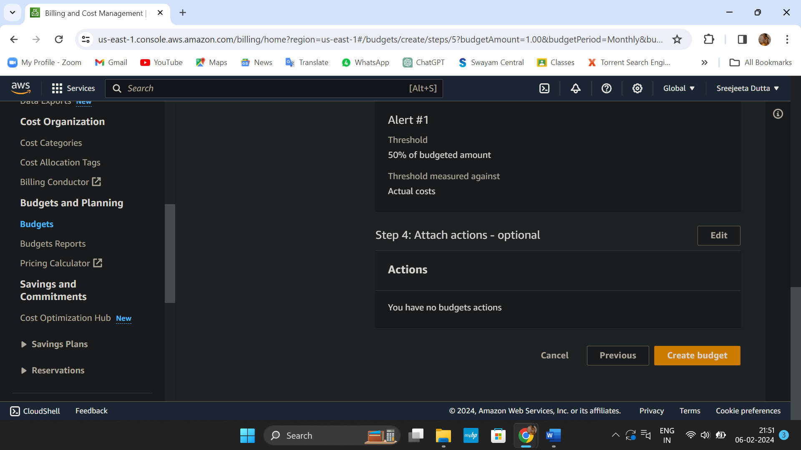

1. Budget created successfully.

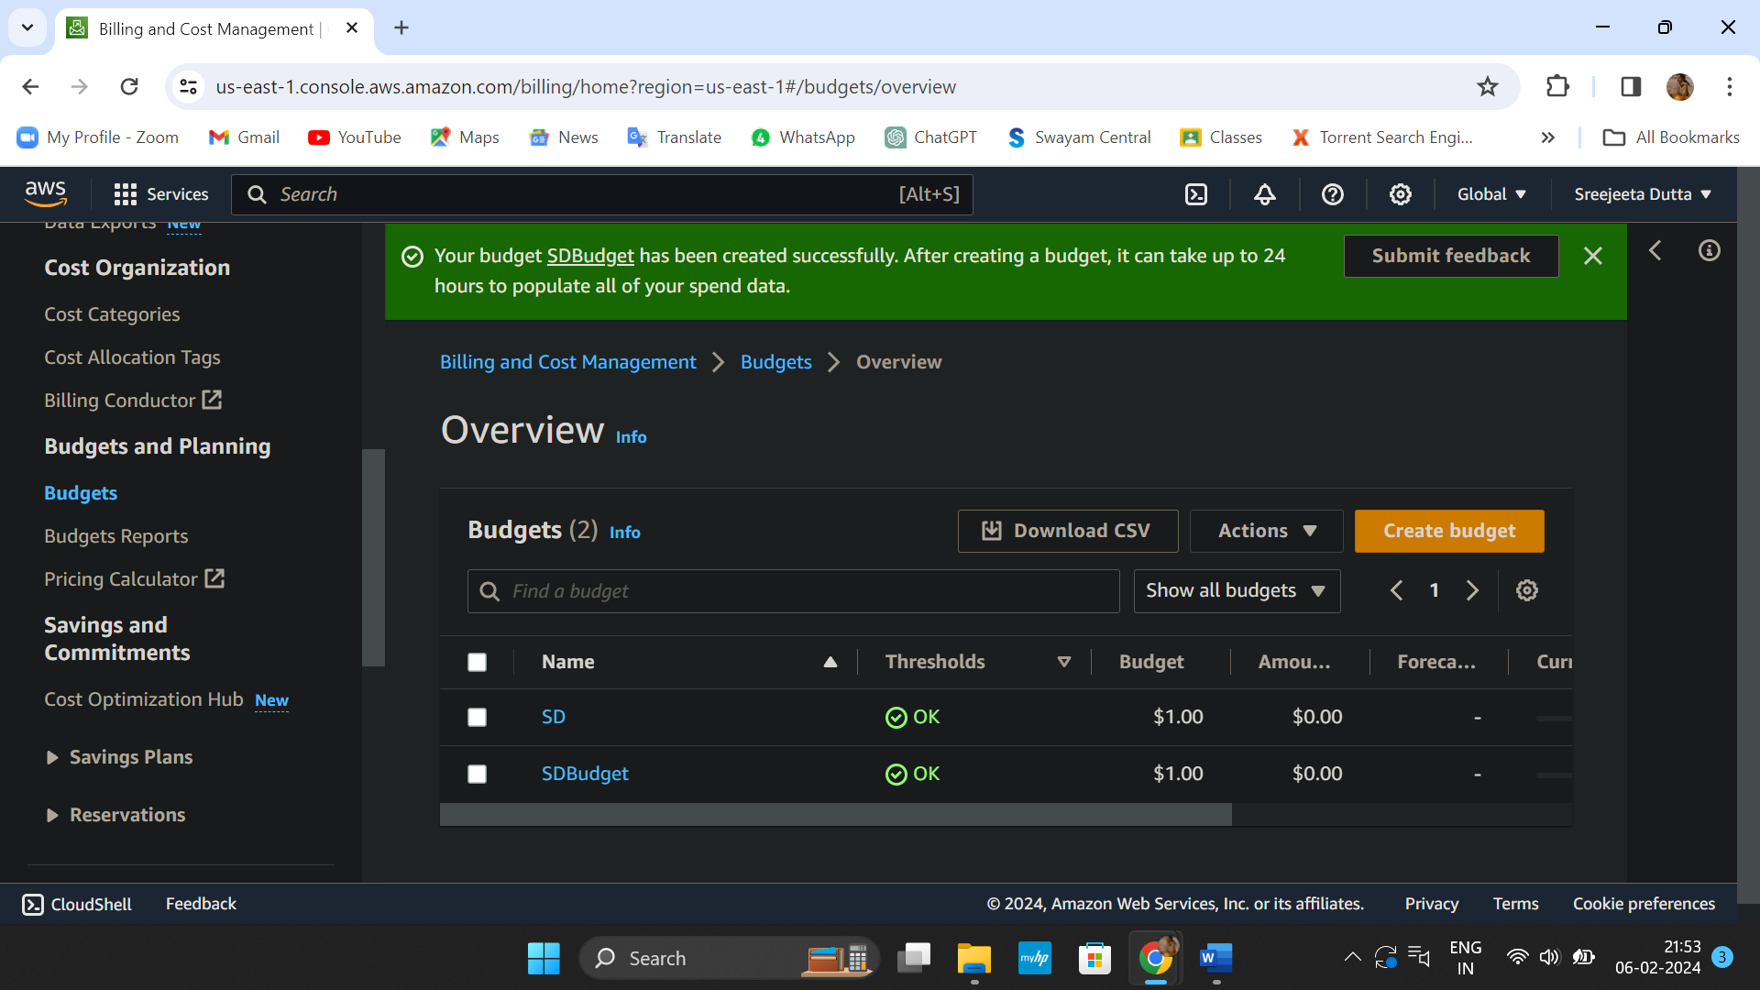

**PROBLEM STATEMENT**

Create MFA for authentication.

1. Log into AWS account and go to security credentials.

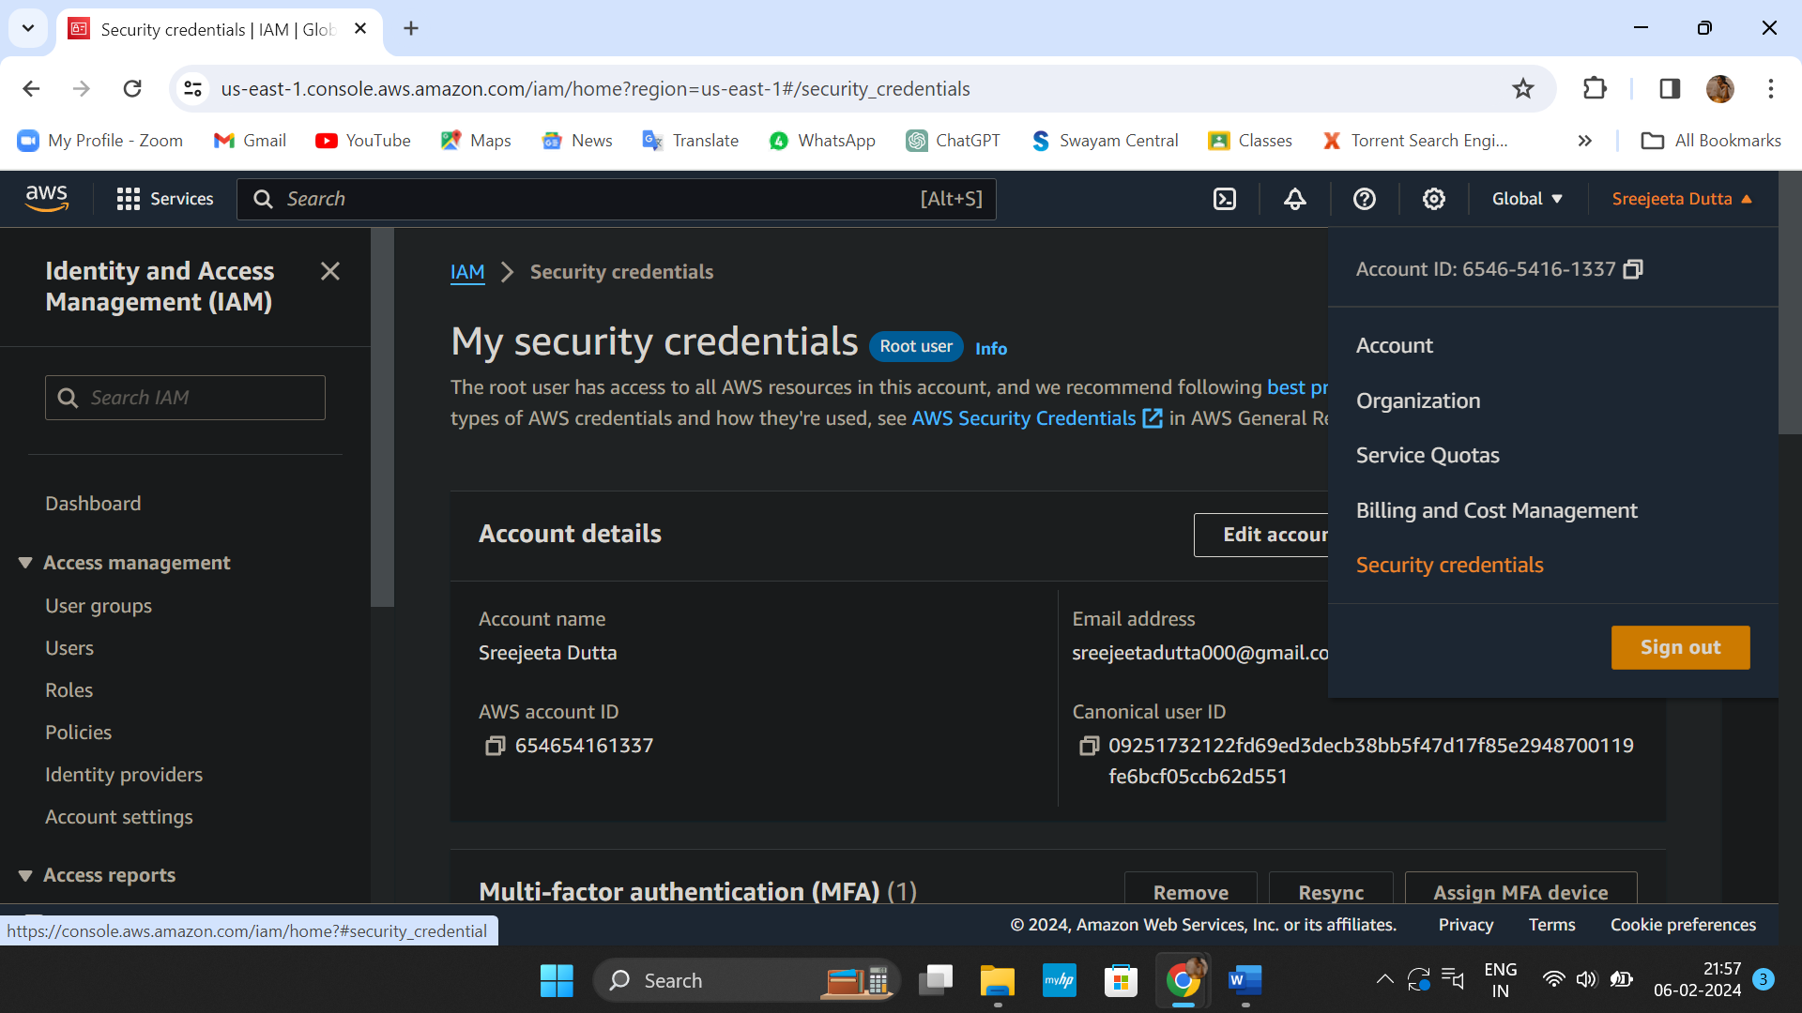

1. Add MFA device by clicking on ‘Assign MFA device’.

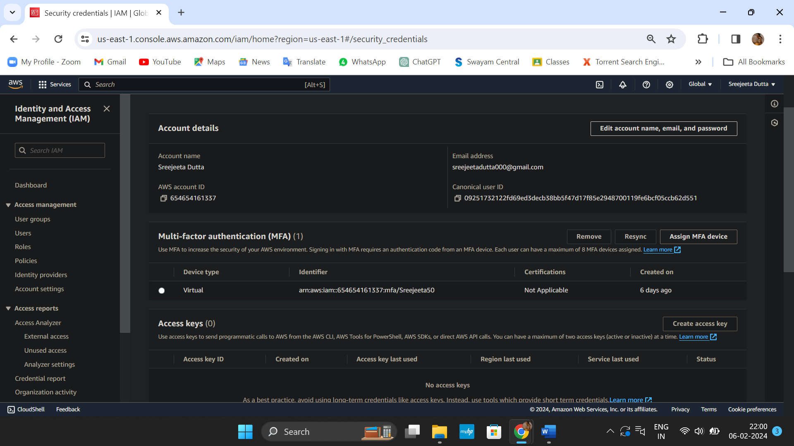

1. Enter device name and click on ‘Next’.

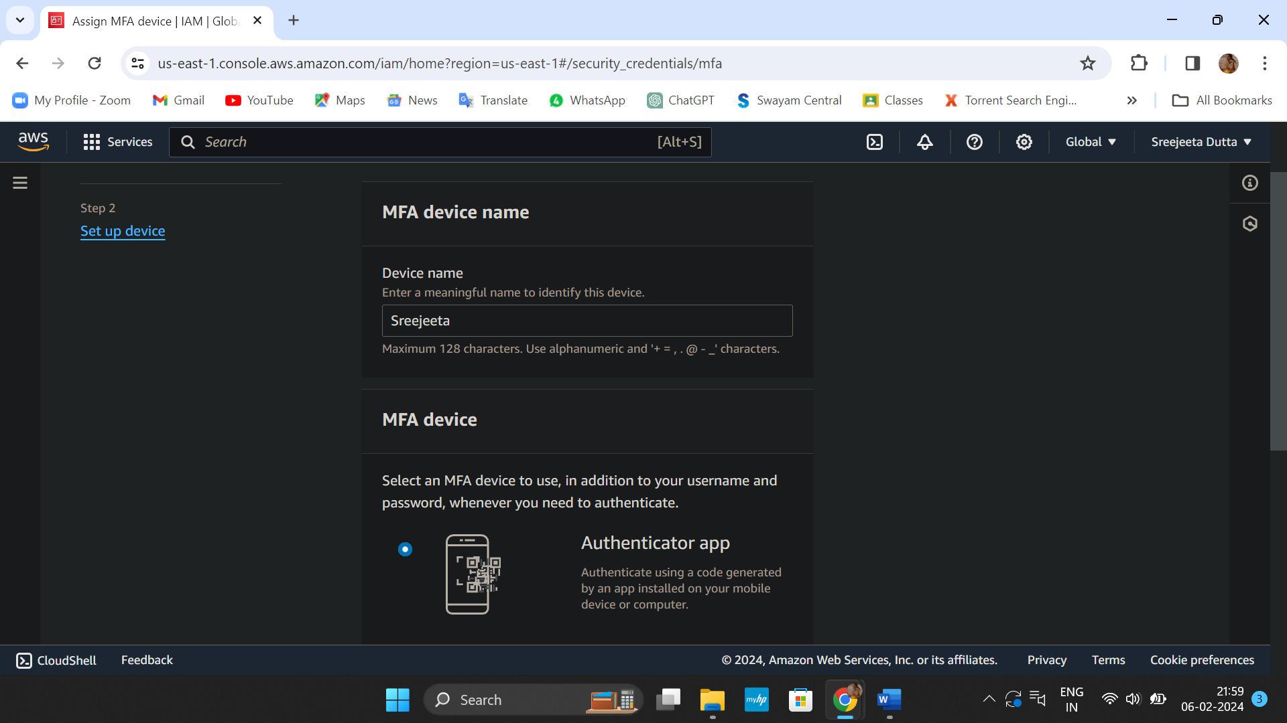

4. Enter code using authenticator app and click on ‘Add MFA’ to complete the process.

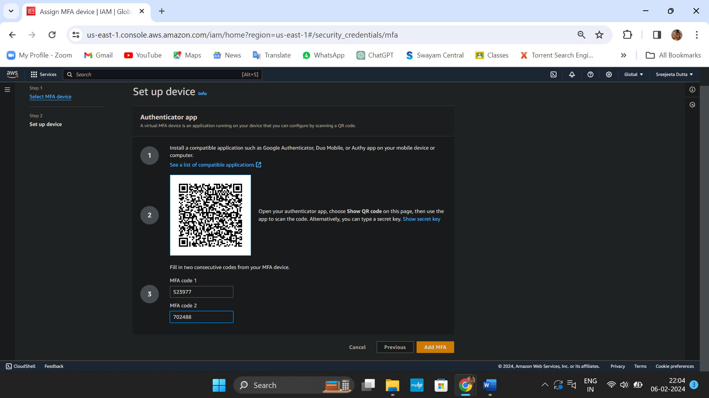

5. MFA device assigned successfully.

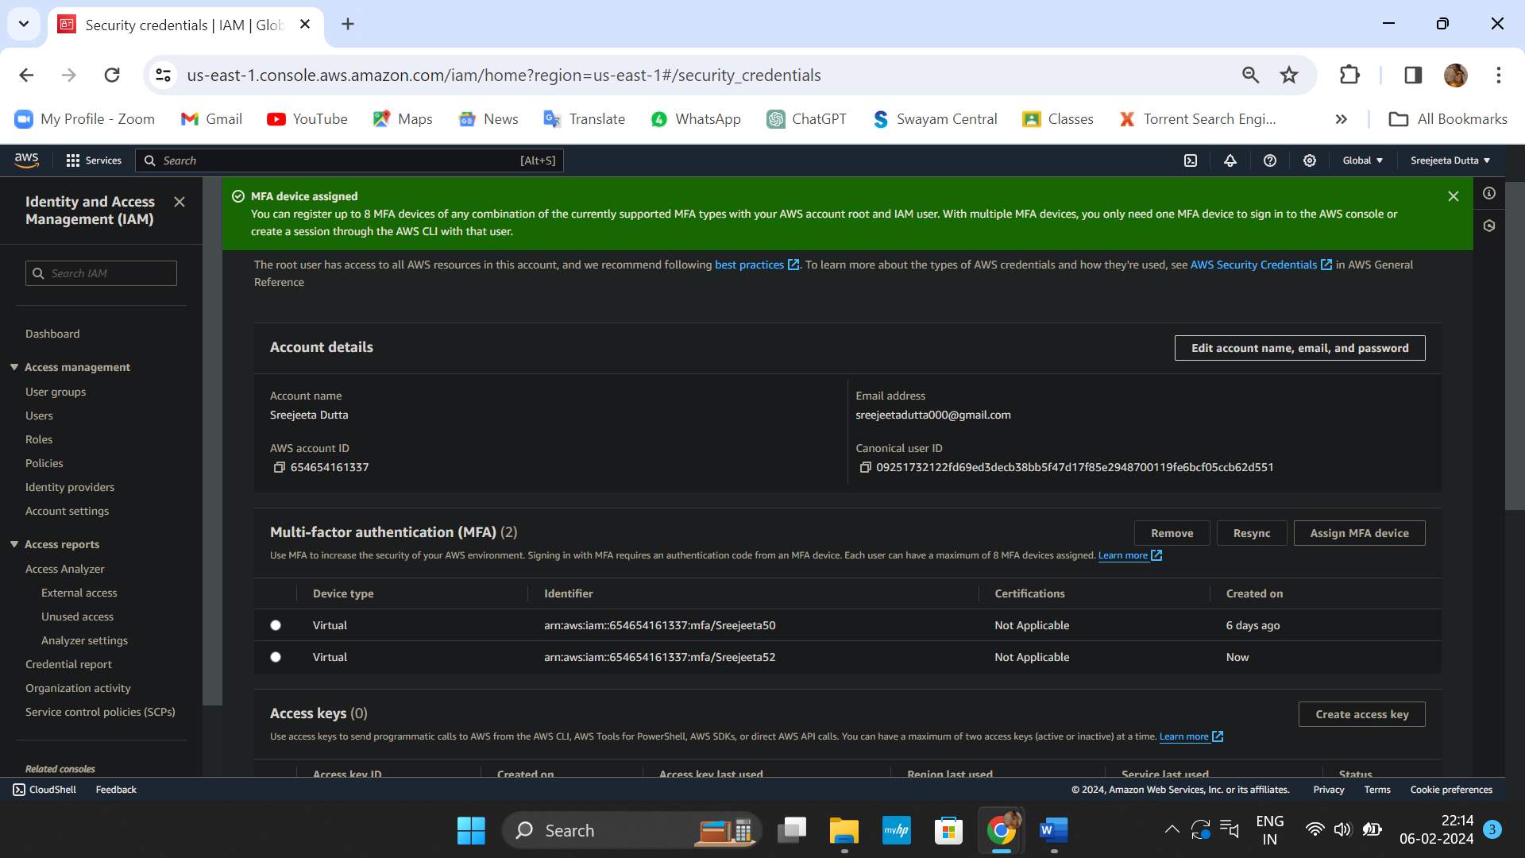

6. Sign out from the console and login again using MFA code.

